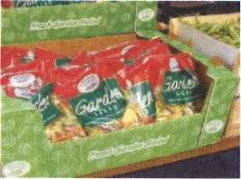
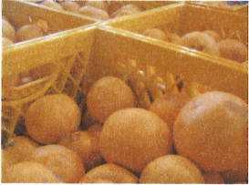
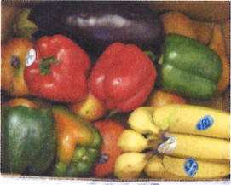
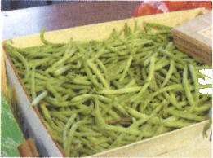
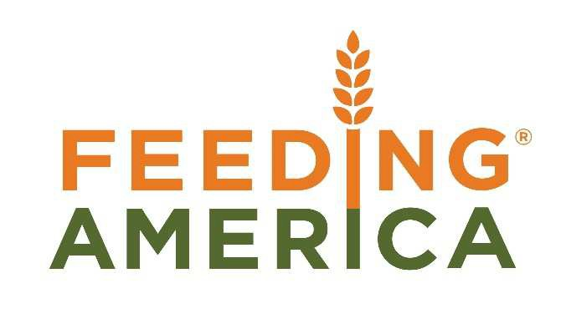

Federal Tax lncentives for Produce Donations
Expanded Tax Law as of 2016

- Enhanced tax deduction available for donations of fit and wholesome food inventory to qualified 501(c)3 nonprofit organizations serving the poor and needy (lnternal Revenue Code 170e3).
.q
Qualified business taxpayers can deduct cost to produce the food and half the difference between the cost and full fair market value of food donated.

Deductions apply to C corporations AND non c corporations as of 2016 with new procedures for growers that are cash basis.

By expanding applicability of the tax benefits to all farmers and producers and by making it permanent it allows farmers to incorporate donation as a regular part of their crop planning, either grown to donate or as an outlet for unmarketable product.

- Provides a protocol not previously available which establishes a Fair Market Value (FMV) of product donated from the farm or packing sheds by utilizing the selling price of goods moved to market.
Special Consideration for Produce Growers
Farmers that use the cash basis method of accounting must use a different way to calculate the enhanced tax deduction.
- Cash balance = recognizes income when cash is received and expenses when cash is paid;

- Farmers prefer cash balance because it does not require the cost of an accountant like the accrual method and is more flexible for tax planning.

- Accrual method = recognizes income when it is earned (accountsreceivable) and expenses when they are incurred (accounts payable).
' Because farmers using cash basis are not tracking cost for specific items closely enough, they must use 25% of the Fair Market Value to calculate their cost and then calculate the enhanced tax deduction.

Liability Protection
The Bill Emerson Good Samaritan Food Donation Act was created to encourage the donation of food and grocery products to 501(c)3 certified nonprofit organizations.
Under this Act, as long as the donor has not acted with negligence or intentional misconduct, the company is not liable for damage incurred as the result of illness.
* See reverse side of page for more information *

Disclaimer: Feeding America offers receipts for tax deductions; please consult your tax advisor for further information.
Please contact Carrie Calvert at ccalvert@feedingamerica.org with any questions. Morch 2075
Philabundance 215-339-0900 Food Acquisition Department

Federal Tax lncentives for Produce Donations

Sample Accrual Accounting Calculations

Your company may take the sum of one-half of the unrealized appreciation (market value minus cost = appreciation) plus the taxpayer's cost, but not in excess of twice the cost of the contributed property.
Example of Zero Cost Donation:
Market Value $10.00
Cost to Produce (Estimating a KNOWN cost) $ 3.50 Gross Profit equals $ 6.50
One-half of $6.50 equals $3.25
The maximum deduction can never exceed 2x cost ($3.50 x2). Therefore, gross profit is limited to $ 7.00
Total charitable deductions: $ 6.75 (doesn't exceed 2x Cost)

Sample Cash Basis Accounting

Sample Enhanced Benefit Calculation:
The sum of one-half of the unrealized appreciation (fair market value minus cost of goods sold = appreciation) plus the taxpayer's cost, but not in excess of twice the cost of the contributed property. If cost is unknown, taxpayer can use 25% of FMV to calculate it.

Example:
Selling Price (FMV) $10.00 Cost of Goods Sold (25% of FMV) $ 2.50 Gross Profit $ 7.50

Previous tax benefit: None
New tax benefit for all cash basis donors:

� $3.75 + $2.50 = $6.25 (1/2 the difference between FMV and COGS + COGS

NOTE: The maximum deduction can never exceed 2 x COGS. So the $6.25 donation is adjusted down to $5.00 (2x COGS).
The Bill Emerson Good Samaritan Food Donation Act

What does the law do?
The law protects good-faith donors from civil and criminal liability, should the product later cause harm to its recipient. The Emerson Act standardizes donor liability exposure. Donors and their legal counsel no longer have to investigate liability laws in 50 states.

Who is protected?
The law protects food donors, including individuals, and non- profit feeding programs who act in good faith. While exceptions are made for gross negligence or intentional misconduct, the law states that these groups will not be subject to civil or criminal liability.

More specifically, the law protects individuals, corporations, partnerships, organizations, associations, government entities, wholesalers, retailers, restauranteurs, caterers, farmers, gleaners, non-profit agencies, and more.

What sort of food is protected?

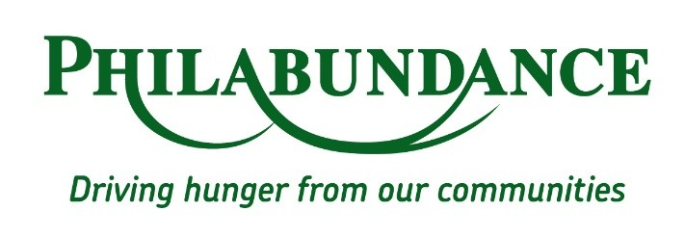
The Emerson Act provides protection for food and grocery products that meet all quality and labeling standards imposed by federal , state, and local laws and regulations even though the food may not be “readily marketable due to appearance, age, freshness, grade, size, surplus or other conditions.”

Philabundance 267-386-2990 DonateProduce@Philabundance.org

